**MODULE 4**

**BALANCE TEAM AND STAKEHOLDER NEEDS**

**ALWAYS REMEMBER THE STAKEHOLDERS**

[**COMMUNICATING WITH YOUR TEAM**](https://www.coursera.org/learn/ask-questions-make-decisions/lecture/86sLz/communicating-with-your-team)

[**BALANCE NEEDS AND EXPECTATIONS ACROSS YOUR TEAM**](https://www.coursera.org/learn/ask-questions-make-decisions/lecture/caTQ9/balance-needs-and-expectations-across-your-team)

**Stakeholders** are people that have invested time, interest, and resources into the projects that you'll be working on as a data analyst. In other words, **they hold stakes in what you're doing.** There's a good chance they'll need the work you do to perform their own needs.

That's why it's so important to make sure your work lines up with their needs and why you need to communicate effectively with all of the stakeholders across your team. Your stakeholders will want to discuss things like the project objective, what you need to reach that goal, and any challenges or concerns you have. This is a good thing. These conversations help build trust and confidence in your work.

You'll find that in pretty much every project you work on as a data analyst, different people on your team, from the VP of HR to your fellow data analysts, will need all your focus and communication to carry the project to success. Focusing on stakeholder expectations will help you understand the goal of a project, communicate more effectively across your team, and build trust in your work.

[**WORKING WITH STAKEHOLDERS**](https://www.coursera.org/learn/ask-questions-make-decisions/supplement/2MAkf/working-with-stakeholders)

Your data analysis project should answer the business task and create opportunities for data-driven decision-making. That's why it is so important to focus on project stakeholders. As a data analyst, it is your responsibility to understand and manage your stakeholders’ expectations while keeping the project goals front and center.



You might remember that **stakeholders** are people who have invested time, interest, and resources into the projects that you are working on. This can be a pretty broad group, and your project stakeholders may change from project to project. But **there are three common stakeholder group**s that you might find yourself working with: the **executive** team, the **customer-facing** team, and the **data science** team.

Let’s get to know more about the different stakeholders and their goals. Then we'll learn some tips for communicating with them effectively.

## **EXECUTIVE TEAM**

The executive team provides strategic and operational leadership to the company. They set goals, develop strategy, and make sure that strategy is executed effectively. The executive team might include vice presidents, the chief marketing officer, and senior-level professionals who help plan and direct the company’s work. These stakeholders think about decisions at a very high level and they are looking for the headline news about your project first. They are less interested in the details. Time is very limited with them, so make the most of it by leading your presentations with the answers to their questions. You can keep the more detailed information handy in your presentation appendix or your project documentation for them to dig into when they have more time.

For example, you might find yourself working with the vice president of human resources on an analysis project to understand the rate of employee absences. A marketing director might look to you for competitive analyses. Part of your job will be balancing what information they will need to make informed decisions with their busy schedule.

But you don’t have to tackle that by yourself. Your project manager will be overseeing the progress of the entire team, and you will be giving them more regular updates than someone like the vice president of HR. They are able to give you what you need to move forward on a project, including getting approvals from the busy executive team. Working closely with your project manager can help you pinpoint the needs of the executive stakeholders for your project, so don’t be afraid to ask them for guidance.



## 

## 

## **CUSTOMER-FACING TEAM**

The customer-facing team includes anyone in an organization who has some level of interaction with customers and potential customers. Typically they compile information, set expectations, and communicate customer feedback to other parts of the internal organization. These stakeholders have their own objectives and may come to you with specific tasks. It is important to let the data tell the story and not be swayed by asks from your stakeholders to find certain patterns that might not exist.

Let’s say a customer-facing team is working with you to build a new version of a company’s most popular product. Part of your work might involve collecting and sharing data about consumers’ buying behavior to help inform product features. Here, you want to be sure that your analysis and presentation focuses on what is actually in the data-- not on what your stakeholders hope to find.



## **DATA SCIENCE TEAM**

Organizing data within a company takes teamwork. There's a good chance you'll find yourself working with other data analysts, data scientists, and data engineers. For example, maybe you team up with a company's data science team to work on boosting company engagement to lower rates of employee turnover. In that case, you might look into the data on employee productivity, while another analyst looks at hiring data. Then you share those findings with the data scientist on your team, who uses them to predict how new processes could boost employee productivity and engagement. When you share what you found in your individual analyses, you uncover the bigger story. A big part of your job will be collaborating with other data team members to find new angles of the data to explore. Here's a view of how different roles on a typical data science team support different functions:

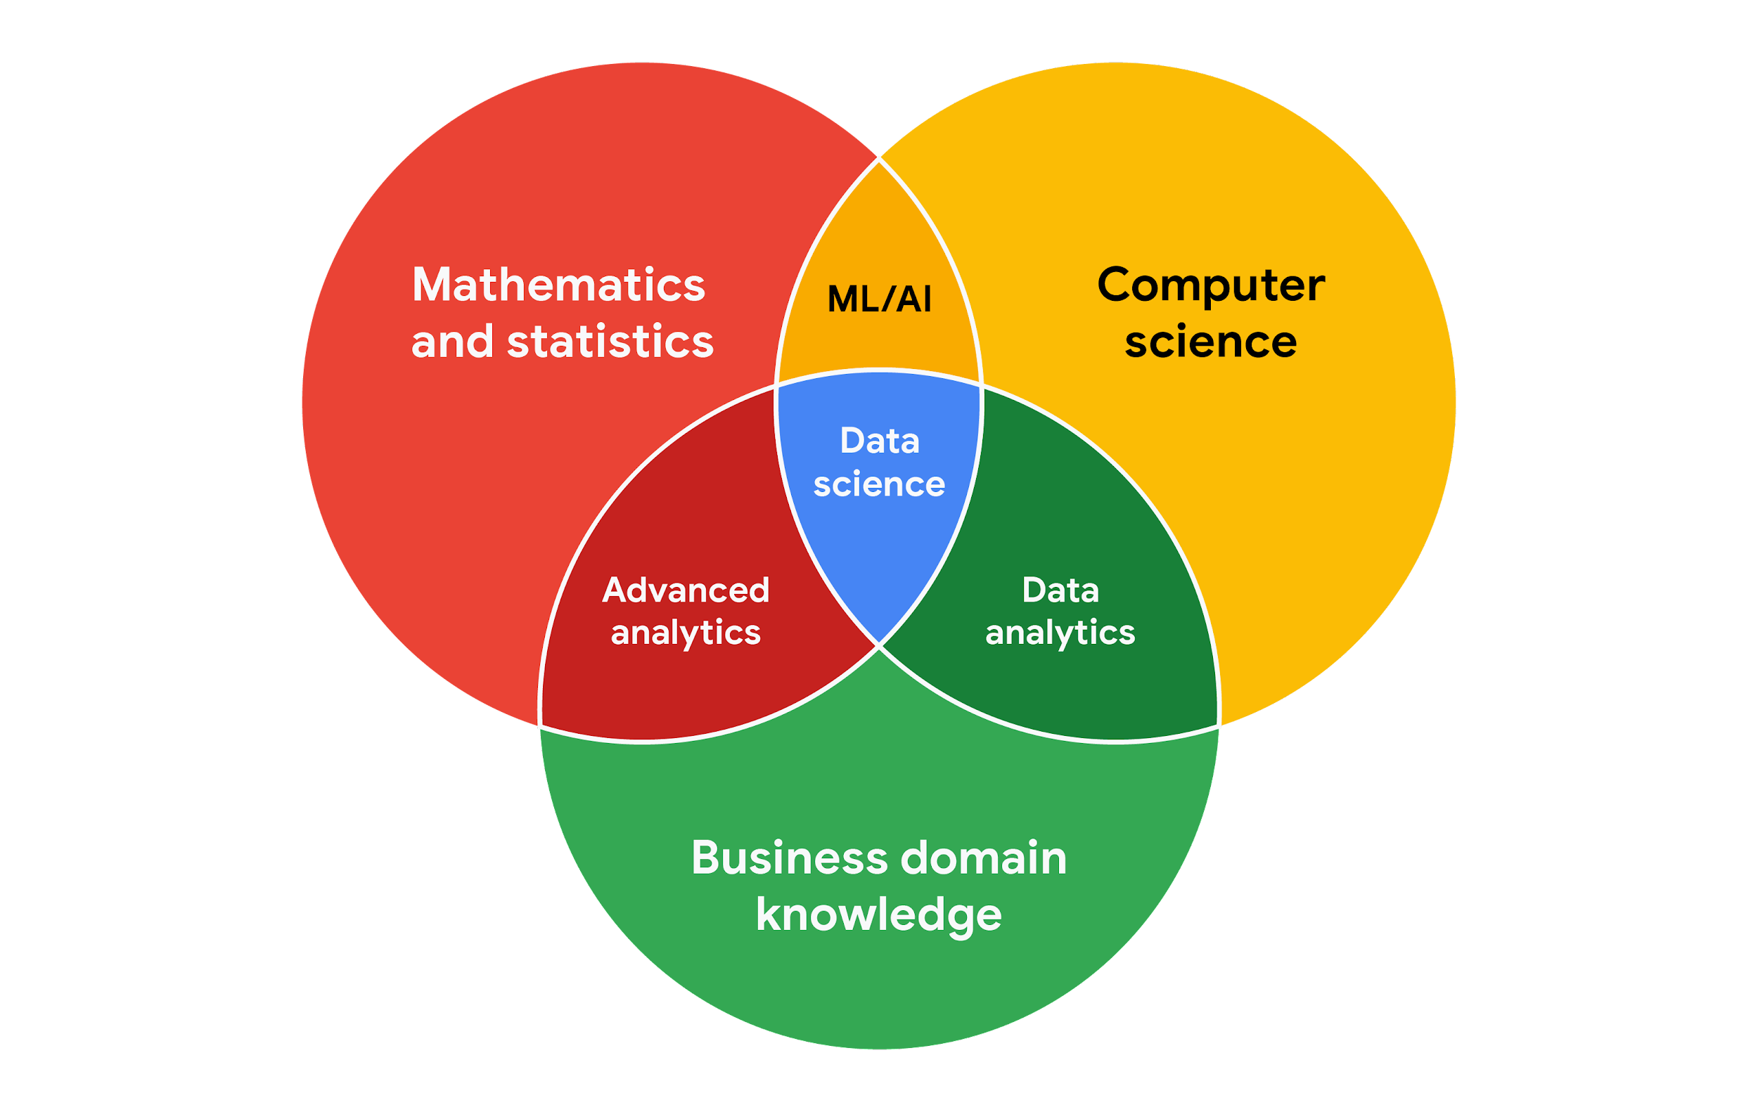

## **WORKING EFFECTIVELY WITH STAKEHOLDERS**

When you're working with each group of stakeholders- from the executive team, to the customer-facing team, to the data science team, you'll often have to go beyond the data. Use the following tips to communicate clearly, establish trust, and deliver your findings across groups.

**Discuss goals.** Stakeholder requests are often tied to a bigger project or goal. When they ask you for something, take the opportunity to learn more. Start a discussion. Ask about the kind of results the stakeholder wants. Sometimes, a quick chat about goals can help set expectations and plan the next steps.

**Feel empowered to say “no**.” Let’s say you are approached by a marketing director who has a “high-priority” project and needs data to back up their hypothesis. They ask you to produce the analysis and charts for a presentation by tomorrow morning. Maybe you realize their hypothesis isn’t fully formed and you have helpful ideas about a better way to approach the analysis. Or maybe you realize it will take more time and effort to perform the analysis than estimated. Whatever the case may be, **don’t be afraid to push back when you need to.**



**Stakeholders** don’t always realize the time and effort that goes into collecting and analyzing data. They also might not know what they actually need. You can help stakeholders by asking about their goals and determining whether you can deliver what they need. If you can’t, have the confidence to say “no,” and provide a respectful explanation. If there’s an option that would be more helpful, point the stakeholder toward those resources. If you find that you need to prioritize other projects first, discuss what you can prioritize and when. When your stakeholders understand what needs to be done and what can be accomplished in a given timeline, they will usually be comfortable resetting their expectations. You should feel empowered to say no-**- just remember to give context so others understand why.**

**Plan for the unexpected.** Before you start a project, make a list of potential roadblocks. Then, when you discuss project expectations and timelines with your stakeholders, give yourself some extra time for problem-solving at each stage of the process.

**Know your project.** Keep track of your discussions about the project over email or reports, and be ready to answer questions about how certain aspects are important for your organization. Get to know how your project connects to the rest of the company and get involved in providing the most insight possible. If you have a good understanding about why you are doing an analysis, it can help you connect your work with other goals and be more effective at solving larger problems.

**Start with words and visuals.** It is common for data analysts and stakeholders to interpret things in different ways while assuming the other is on the same page. This *illusion of agreement\**has been historically identified as a cause of projects going back-and-forth a number of times before a direction is finally nailed down. To help avoid this, start with a description and a quick visual of what you are trying to convey. Stakeholders have many points of view and may prefer to absorb information in words or pictures. Work with them to make changes and improvements from there. The faster everyone agrees, the faster you can perform the first analysis to test the usefulness of the project, measure the feedback, learn from the data, and implement changes.

**Communicate often.** Your stakeholders will want regular updates on your projects. Share notes about project milestones, setbacks, and changes. Then use your notes to create a shareable report. Another great resource to use is a change-log, which is a tool that will be explored further throughout the program. For now, just know that a change-log is a file containing a chronologically ordered list of modifications made to a project. Depending on the way you set it up, stakeholders can even pop in and view updates whenever they want.



*\*Jason Fried, Basecamp,* [*www.inc.com/magazine/201809/jason-fried/illusion-agreement-team-project.html*](https://www.inc.com/magazine/201809/jason-fried/illusion-agreement-team-project.html)

**[FOCUS ON WHAT MATTERS](https://www.coursera.org/learn/ask-questions-make-decisions/lecture/QJ5qG/focus-on-what-matters)**

[**UNDERSTANDING STAKEHOLDER ROLES**](https://www.coursera.org/learn/ask-questions-make-decisions/ungradedWidget/7C7sg/understanding-stakeholder-roles)

**CLEAR COMMUNICATION IS KEY**

**CLEAR COMMUNICATION IS KEY**

[Here's the secret to effective communication. Before you put together a presentation, think about **who your audience is(1)**, **what** **they already know(2)**, **what they need to know(3) and how you can communicate that effectively to them(4)**. When you start by thinking about your audience, they'll know it and appreciate the time you took to consider them and their needs .](https://www.coursera.org/learn/ask-questions-make-decisions/ungradedWidget/7C7sg/understanding-stakeholder-roles)

[**TIPS FOR EFFECTIVE COMMUNICATION**](https://www.coursera.org/learn/ask-questions-make-decisions/lecture/VCh1T/tips-for-effective-communication)

[No matter where you work, you'll probably need to communicate with other people as part of your day to day. Every organization and every team in that organization will have different expectations for communication.](https://www.coursera.org/learn/ask-questions-make-decisions/ungradedWidget/7C7sg/understanding-stakeholder-roles)

If you find your team uses **acronyms** you aren't familiar with, don't be afraid to ask what they mean.

When I first started at google, I had no idea what L G T M meant and I was always seeing it in comment threads. Well, I learned it stands for looks good to me and I use it all the time now if I need to give someone my quick feedback, that was one of the many acronyms I've learned and I come across new ones all the time and **I'm never afraid to ask**.

**Every work setting has some form of etiquette.**

You'll want your **emails** to be just as **professional** as your in-person communications. Emails are naturally more formal than texts, but that doesn't mean that you have to write the next great novel. Just taking the time to write complete sentences that have proper spelling and punctuation will make it clear you took time and consideration in your writing. **Write clearly enough that anyone could understand you.**

I like to read important emails out loud before I hit send; that way, I can hear if they make sense and catch any typos.

Keep in mind the tone of your emails can change over time. If you find that your team is fairly casual, that's great. Once you get to know them better, you can start being more casual too, but **being professional is always a good place to start.**

**A good rule of thumb:** Would you be proud of what you had written if it were published on the front page of a newspaper? If not, revise it until you are. You also don't want your emails to be too long.

**Think about what your team member needs to know** **and get to the point** instead of overwhelming them with a wall of text. You'll want to make sure that your emails are clear and concise so they don't get lost in the shuffle.

[.](https://www.coursera.org/learn/ask-questions-make-decisions/ungradedWidget/7C7sg/understanding-stakeholder-roles)

[**USE MULTIPLE COMMUNICATION STRATEGIES TO REACH YOUR AUDIENCE**](https://www.coursera.org/learn/ask-questions-make-decisions/supplement/WmZKd/use-multiple-communication-strategies-to-reach-your-audience)

**Being able to communicate in multiple formats is a key skill for data analysts**. Listening, speaking, presenting, and writing skills will help you succeed in your projects and in your career. This reading covers effective communication strategies, including examples of clearly worded emails for common situations.

Here's an important first tip: Know your audience! When you communicate your analysis and recommendations as a data analyst, it's vital to keep your audience in mind.

Be sure to answer these four important questions related to your audience:

1. **Who is your audience?**
2. **What do they already know?**
3. **What do they need to know?**
4. **How can you best communicate what they need to know?**

## 

## **Project example**

As a data analyst, you'll get plenty of requests and questions through email. Let’s walk through an example of how you might approach answering one of these emails. Assume you're a data analyst working at a company that develops mobile apps. Let's start by reviewing answers to the four audience questions we just covered:



Kiri, Product Development Project Manager



Kiri received updates about our project from its planning stages, including the most recent project report**,** sent two weeks ago.

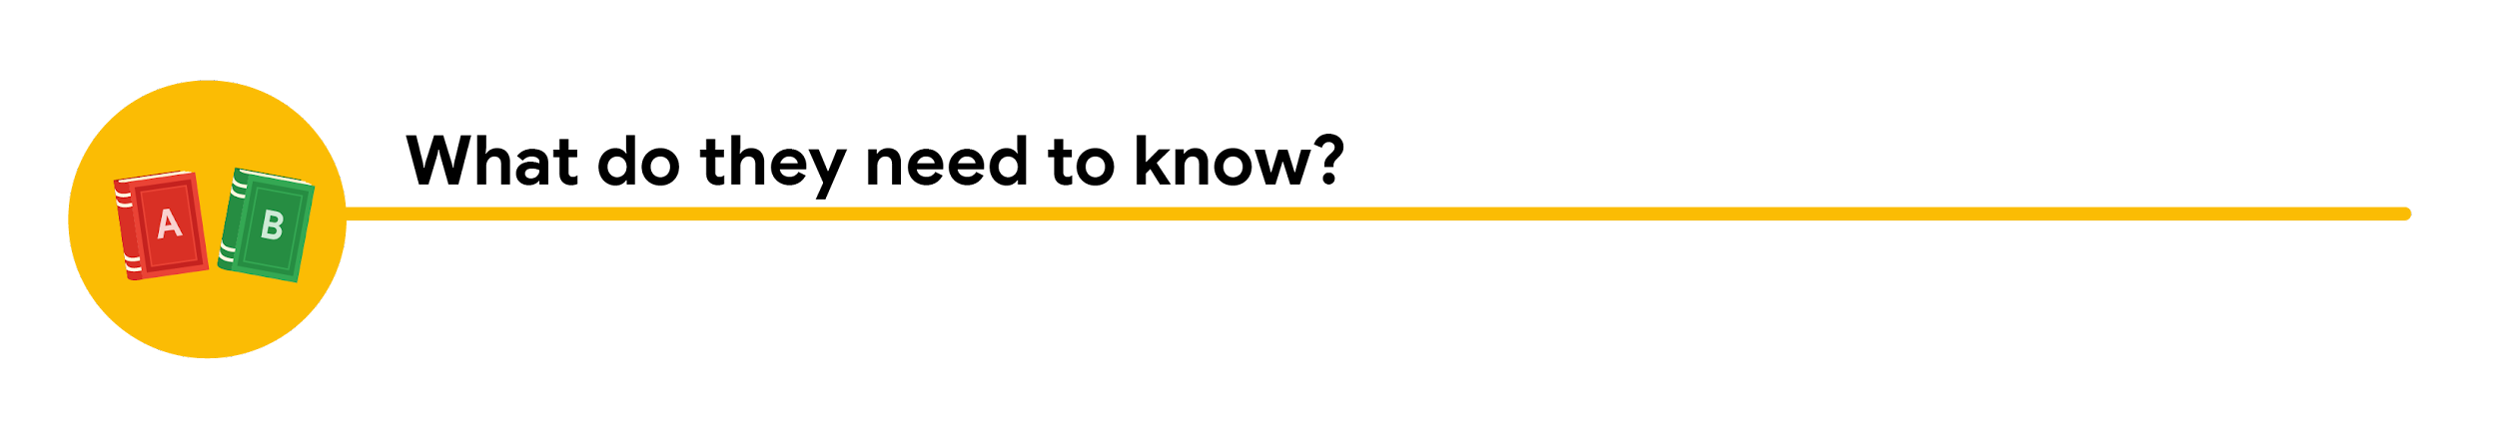

Kiri needs an update on the analysis project’s progress and needs to know that the executive team approved changes to the data and timeline. You know that adding a new variable to the analysis will impact the current project timeline. Kiri will need to change the project’s milestones and completion date.

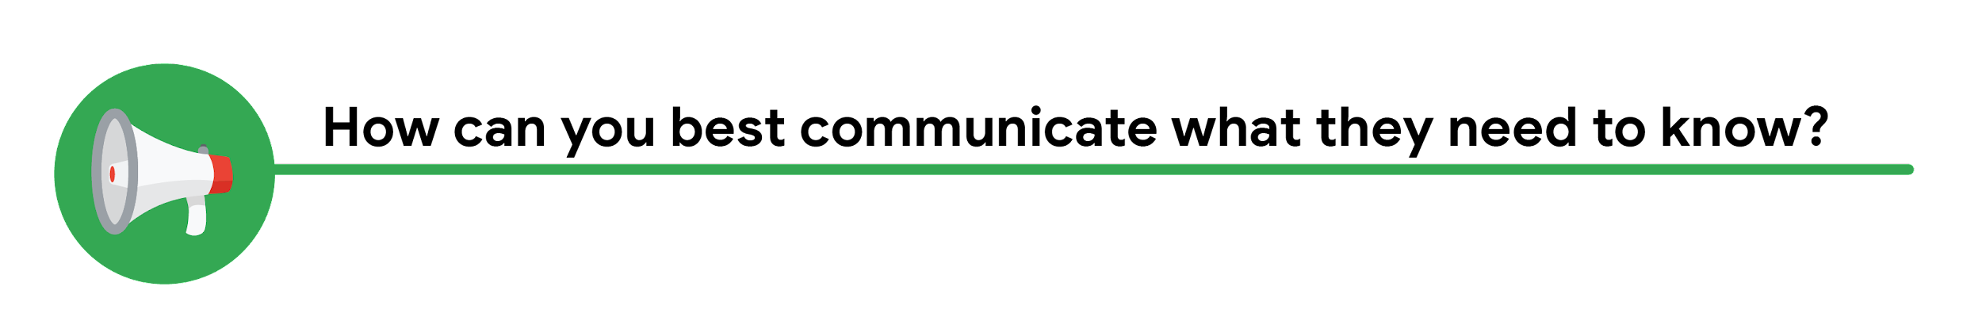

You can start by sending an email update to Kiri with the latest timeline for the project, but a meeting might be necessary if she wants to talk through her concerns about missing a deadline.

## **Updated timeline email sample**

After answering the audience questions, you have the **key building blocks** you need to write an **email** to Kiri. Here's an example of how these questions can help organize the flow of the email message:

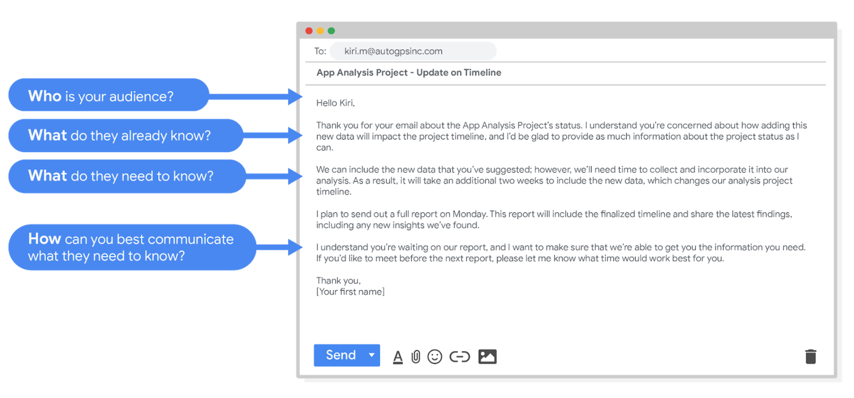

Hello Kiri, (who is your audience?)

Thank you for your email about the app analysis project's status. I understand you're concerned about how adding this new data will impact the project timeline, and I'd be glad to provide as much information about the project status as I can. (What do they already know? )

We can include the new data that you've suggested; however, we'll need time to collect and incorporate it into our analysis. As a result, it will take an additional two weeks to include the new data, which changes our analysis project timeline. (What do they need to know?)

I plan to send out a full report on Monday. This report will include the finalized timeline and share the latest findings, including any new insights we've found.

I understand you're waiting on our report, and I want to make sure that we're able to get you the information you need. If you'd like to meet before the next report, please let me know what time would work best for you. (How can you best communicate what they need to know?)

Thank you,

(your first name)

After receiving your email, Kiri will have a clearer view of the changes to the analysis project and will be able to make adjustments to work with the new timeline.

## **Project follow-up email sample**

After the next report is completed, you can also send out a project update offering more information. The email could look like this:

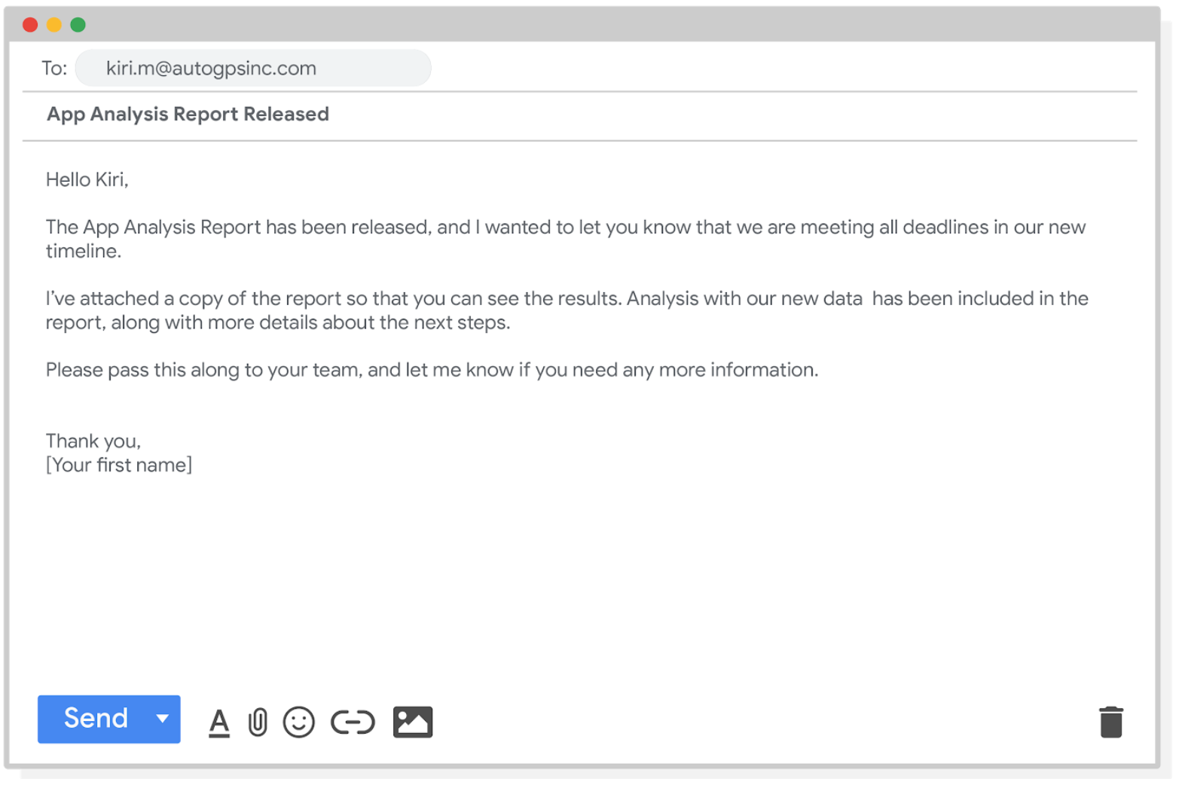

“Hello Kiri,

The app analysis report has been released, and I wanted to let you know that we are meeting all deadlines in our new timeline.

I've attached a copy of the report so that you can see the results. Analysis with our new data has been included in the report, along with more details about the next steps.

Please pass this along to your team, and let me know if you need any more information.

Thank you,

[your first name]”

**Good communication keeps stakeholders updated on progress and ultimately helps prevent problems**. Carefully worded responses are key. Whether you gather and address feedback using email, meetings, or reports, everyone you work with will know what to expect. As a result, they will be able to better manage their own schedules, resources, and teams.

[**NAVIGATE EXPECTATIONS AND REALISTIC PROJECT GOALS**](https://www.coursera.org/learn/ask-questions-make-decisions/lecture/haLKs/navigate-expectations-and-realistic-project-goals)

We discussed before how data has limitations. Sometimes you don't have access to the data you need, or your data sources aren't aligned or your data is unclean. This can definitely be a problem when you're analyzing data, but it can also affect your communication with your stakeholders. That's why it's important to balance your stakeholders' expectations with what is actually possible for a project. We're going to learn about the importance of setting realistic, objective goals and how to best communicate with your stakeholders about problems you might run into.Keep in mind that a lot of things depend on your analysis. **In some situations it's important to loop stakeholders in.** For example, telling your project manager if you're on schedule or if you're having a problem.

**Example:**

Let's say you're working on a project for an insurance company. The company wants to identify common causes of minor car accidents so that they can develop educational materials that encourage safer driving. There's a few early questions you and your team need to answer.

**What driving habits will you include in your dataset?**

**How will you gather this data?**

**How long will it take you to collect and clean that data before you can use it in your analysis?**

**Right away you want to communicate clearly with your stakeholders to answer these questions, so you and your team can set a reasonable and realistic timeline for the project**. It can be tempting to tell your stakeholders that you'll have this done in no time, no problem. But **setting expectations for a realistic timeline will help you in the long run.** Your stakeholders will know what to expect when, and you won't be overworking yourself and missing deadlines because you over promised. I find that **setting expectations early helps me spend my time more productively.** So as you're getting started, you'll want to send a high-level schedule with different phases of the project and their approximate start dates.

In this case, you and your teams establish that you'll need three weeks to complete analysis and provide recommendations, and you let your stakeholders know so they can plan accordingly.

Now let's imagine you're further along in the project and **you run into a problem.** Maybe drivers have opted into sharing data about their phone usage in the car, but you discover that some sources count GPS usage, and some don't in their data. This might add time to your data processing and cleaning and delay some project milestones. **You'll want to let your project manager know and maybe work out a new timeline to present to stakeholders.** **The earlier you can flag these problems, the better.** That way your stakeholders can make necessary changes as soon as possible. Or what if your stakeholders want to add car model or age as possible variables. You'll have to communicate with them about how that might change the model you've built, if it can be added and before the deadlines, and any other obstacles that they need to know so they can decide if it's worth changing at this stage of the project. **To help them you might prepare a report on how their request changes the project timeline or alters the model**. **You could also outline the pros and cons of that change**. You want to help your stakeholders achieve their goals, but it's important to set realistic expectations at every stage of the project. This takes some balance.

You've learned about balancing the needs of your team members and stakeholders, but **you also need to balance stakeholder expectations and what's possible with the projects, resources, and limitations.** That's why it's important to be realistic and objective and communicate clearly. This will help stakeholders understand the timeline and have confidence in your ability to achieve those goals. So we know communication is key and we have some good rules to follow for our professional communication

[**SARAH: HOW TO COMMUNICATE WITH STAKEHOLDERS**](https://www.coursera.org/learn/ask-questions-make-decisions/lecture/P8G1s/sarah-how-to-communicate-with-stakeholders)

As a data analyst, there's going to be times where you have **different stakeholders who have no idea about the amount of time that it takes you to do each project**, and in the very beginning when I'm asked to do a project or to look into something, I always try to give a little bit of expectation settings on the turn around because **most of your stakeholders don't really understand what you do with data and how you get it and how you clean it and put together the story behind it**.

The other thing that **I want to make clear to everyone is that you have to make sure that the data tells you the stories**.

Sometimes **people think that data can answer everything and sometimes we have to acknowledge that that is simply untrue**. I recently worked with a state to figure out why people weren't signing up for the benefits that they needed and deserved. We saw people coming to the site and where they would sign up for those benefits and see if they're qualified. But for some reason there was something stopping them from taking the step of actually signing up. So I was able to look into it using Google Analytics to try to uncover what is stopping people from taking the action of signing up for these benefits that they need and deserve. And so I go into Google Analytics, I see people are going back between this service page and the unemployment page back to the service page, back to the unemployment page. And so I came up with a theory that hey, people aren't finding the information that they need in order to take the next step to see if they qualify for these services. The only way that I can actually know why someone left the site without taking action is if I ask them. I would have to survey them. Google Analytics did not give me the data that I would need to 100% back my theory or deny it. **So when you're explaining to your stakeholders**, **"Hey I have a theory. This data is telling me a story. However I can't 100% know due to the limitations of data,"** You just have to say it. So the way that I communicate that is I say **"I have a theory that people are not finding the information that they need in order to take action. Here's the proof that I have that supports that theory."** So what we did was we then made it a little bit easier to find that information. Even though we weren't 100% sure that my theory was correct, we were confident enough to take action and then we looked back, and we saw all the metrics that pointed me to this theory improve. And so that **always feels really good when you're able to help a cause that you believe in, do better, and help more people through data. It makes all the nerdy learning about SQL and everything completely worth it.**

[**THE DATA TRADEOFF: SPEED VERSUS ACCURACY**](https://www.coursera.org/learn/ask-questions-make-decisions/lecture/RP0iH/the-data-tradeoff-speed-versus-accuracy)

**We live in a world that loves instant gratification**, whether it's overnight delivery or on-demand movies. We want what we want and we want it now.

But **in the data world, speed can sometimes be the enemy of accuracy, especially when collaboration is required**. We're going to talk about how to balance speedy answers with right ones and how to best address these issues by re-framing questions and outlining problems. That way your team members and stakeholders understand what answers they can expect when.

As data analysts, we need to know the reason behind things like a sales slump, a player's batting average, or rainfall totals. **It's not just about the figures, it's about the context too and getting to the bottom of these things takes time**. So if a stakeholder comes knocking on your door, **a lot of times that person may not really know what they need**. **They just know they want it at light speed**. But sometimes the pressure gets to us and even the most experienced data analysts can be tempted to cut corners and provide flawed or unfinished data in the interest of time. When that happens, so much of the story in the data gets lost. **That's why communication is one of the most valuable tools for working with teams. It's important to start with structured thinking and a well-planned scope of work**, which we talked about earlier. **If you start with a clear understanding of your stakeholders' expectations**, you can then develop a **realistic scope of work that outlines agreed upon expectations, timelines, milestones, and reports.** This way, your team always has a **road map to guide their actions**. If you're pressured for something that's outside of the scope, you can feel confidence setting more realistic expectations. **At the end of the day, it's your job to balance fast answers with the right answers.** Not to mention figuring out what the person is really asking.

**Example:** Imagine your VP of HR shows up at your desk demanding to see how many new hires are completing a training course they've introduced. She says, "There's no way people are going through each section of the course. The human resources team is getting slammed with questions. We should probably just cancel the program." How would you respond? Well, you could log into the system, crunch some numbers, and hand them to your supervisor. That would take no time at all. But the quick answer might not be the most accurate one. So instead, **you could re-frame her question, outline the problem, challenges, potential solutions, and time-frame**. You might say, "I can certainly check out the rates of completion, but I sense there may be more to the story here. Could you give me two days to run some reports and learn what's really going on?" **With more time, you can gain context.** You and the VP of HR decide to expand the project timeline, so you can spend time gathering anonymous survey data from new employees about the training course. Their answers provide data that can help you pinpoint exactly why completion rates are so low. Employees are reporting that the course feels confusing and outdated. Because you were able to take time to address the bigger problem, the VP of HR has a better idea about why new employees aren't completing the course and can make new decisions about how to update it. Now the training course is easy to follow and the HR department isn't getting as many questions. Everybody benefits. Redirecting the conversation will help you find the real problem which leads to more insightful and accurate solutions.

But it's **important to keep in mind**, **sometimes you need to be the bearer of bad news and that's okay.** Communicating about problems, potential solutions and different expectations can help you move forward on a project instead of getting stuck.

**When it comes to communicating answers with your teams and stakeholders, the fastest answer and the most accurate answer aren't usually the same answer.** But by making sure that you understand their needs and setting expectations clearly, you can balance speed and accuracy. Just make sure to be clear and upfront and you'll find success.

[**LIMITATIONS OF DATA**](https://www.coursera.org/learn/ask-questions-make-decisions/supplement/gqKDr/limitations-of-data)

**DATA IS POWERFUL, BUT IT HAS ITS LIMITATIONS.**

**Has someone’s personal opinion found its way into the numbers?**

**Is your data telling the whole story?**

**Part of being a great data analyst is knowing the limits of data and planning for them.**

This reading explores how you can do that.

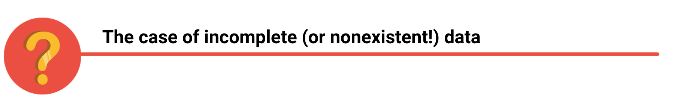

If you have incomplete or nonexistent data, you might realize during an analysis that you don't have enough data to reach a conclusion. Or, you might even be solving a different problem altogether! For example, suppose you are looking for employees who earned a particular certificate but discover that certification records go back only two years at your company. You can still use the data, but you will need to make the limits of your analysis clear. You might be able to find an alternate source of the data by contacting the company that led the training. But to be safe, you should be up front about the incomplete dataset until that data becomes available.



If you're collecting data from other teams and using existing spreadsheets, it is good to keep in mind that people use different business rules. So one team might define and measure things in a completely different way than another. For example, if a metric is the total number of trainees in a certificate program, you could have one team that counts every person who registered for the training, and another team that counts only the people who completed the program. In cases like these, establishing how to measure things early on standardizes the data across the board for greater reliability and accuracy. This will make sure comparisons between teams are meaningful and insightful.



Dirty data refers to data that contains errors. Dirty data can lead to productivity loss, unnecessary spending, and unwise decision-making. A good data cleaning effort can help you avoid this. As a quick reminder, data cleaning is the process of fixing or removing incorrect, corrupted, incorrectly formatted, duplicate, or incomplete data within a dataset. When you find and fix the errors - while tracking the changes you made - you can avoid a data disaster. You will learn how to clean data later in the training.



Avinash Kaushik, a Digital Marketing Evangelist for Google, has lots of great tips for data analysts in his [blog: Occam's Razor](http://www.kaushik.net/). Below are some of the best practices he recommends for good data storytelling:

* **Compare the same types of data**: Data can get mixed up when you chart it for visualization. Be sure to compare the same types of data and double check that any segments in your chart definitely display different metrics.
* **Visualize with care**: A 0.01% drop in a score can look huge if you zoom in close enough. To make sure your audience sees the full story clearly, it is a good idea to set your Y-axis to 0.
* **Leave out needless graphs:** If a table can show your story at a glance, stick with the table instead of a pie chart or a graph. Your busy audience will appreciate the clarity.
* **Test for statistical significance:** Sometimes two datasets will look different, but you will need a way to test whether the difference is real and important. So remember to run statistical tests to see how much confidence you can place in that difference.
* **Pay attention to sample size**: Gather lots of data. If a sample size is small, a few unusual responses can skew the results. If you find that you have too little data, be careful about using it to form judgments. Look for opportunities to collect more data, then chart those trends over longer periods.



In any organization, a big part of a data analyst’s role is making sound judgments. **When you know the limitations of your data, you can make judgment calls that help people make better decisions supported by the data.** Data is an extremely powerful tool for decision-making, but if it is incomplete, misaligned, or hasn’t been cleaned, then it can be misleading. **Take the necessary steps to make sure that your data is complete and consistent. Clean the data before you begin your analysis to save yourself and possibly others a great amount of time and effort.**

[**THINK ABOUT YOUR PROCESS AND OUTCOME**](https://www.coursera.org/learn/ask-questions-make-decisions/lecture/gPuXV/think-about-your-process-and-outcome)

**Data has the power to change the world**.

**Example:**

Think about this. A bank identifies 15 new opportunities to promote a product, resulting in $120 million in revenue. A distribution company figures out a better way to manage shipping, reducing their cost by $500,000. Google creates a new tool that can identify breast cancer tumors in nearby lymph nodes. These are all amazing achievements, but do you know what they have in common? They're all the results of data analytics. You absolutely have the power to change the world as a data analyst. And it starts with how you share data with your team. In this video, we will think through all of the variables you should consider when sharing data.

When you successfully deliver data to your team, you can ensure that they're able to make the best possible decisions. Earlier we learned that speed can sometimes affect accuracy when sharing database information with a team. That's why you need a solid process that weighs the outcomes and actions of your analysis. **So where do you start?** Well, the best solutions start with questions.

Stakeholders will have a lot of questions but it's up to you to figure out what they really need. So ask yourself:   
  
**Does your analysis answer the original question?(1)**

**Are there other angles you haven't considered?** **(2)**

**Can you answer any questions that may get asked about your data and analysis?** **(3)**

**That last question brings up something else to think about. How detailed should you be when sharing your results? (4)**

**Would a high level analysis be okay?(5)**

Above all else, **your data analysis should help your team make better, more informed decisions.**

**Another example:**

Imagine a landscaping company is facing rising costs and they can't stay competitive in the bidding process. One question you could ask to solve this problem is, can the company find new suppliers without compromising quality? If you gave them a high-level analysis, you'd probably just include the number of clients and cost of supplies.

Here your stakeholder might object. She's worried that reducing quality will limit the company's ability to stay competitive and keep customers happy. Well, she's got a point. In that case, you need to provide a more detailed data analysis to change her mind. This might mean exploring how customers feel about different brands. You might learn that customers don't have a preference for specific landscape brands. So the company can change to the more affordable suppliers without compromising quality.

If you feel comfortable using the data to answer all these questions and considerations, you've probably landed on a solid conclusion. Nice! Now that you understand some of the variables involved with sharing data with a team, like process and outcome, you're one step closer to making sure that your team has all the information they need to make informed, data-driven decisions.

**AMAZING TEAMWORK**

[**MEETING BEST PRACTICES**](https://www.coursera.org/learn/ask-questions-make-decisions/lecture/G8ECS/meeting-best-practices)

Meetings are a huge part of how you communicate with team members and stakeholders.

At their core, meetings make it possible for you and your team members or stakeholders to discuss how a project is going. But **they can be so much more than that**. Whether they're virtual or in person, **team meetings can build trust and team spirit**. They give you a chance to connect with the people you're working with beyond emails.

Another benefit is that knowing who you're working with can give you a better perspective of where your work fits into the larger project. **Regular meetings also make it easier to coordinate team goals, which makes it easier to reach your objectives.** With everyone on the same page, your team will be in the best position to help each other when you run into problems too.

**There are some really simple things you can do to make a great meeting:**

**Come prepared, be on time, pay attention, and ask questions.** This applies to both meetings you lead and ones you attend.

What do I mean when I say come prepared? Well, a few things. First, bring what you need. If you like to take notes, have your notebook and pens in your bag or your work device on hand. Being prepared also means **you should read the meeting agenda ahead of time and be ready to provide any updates on your work**.

If you're leading the meeting, make sure to prepare your notes and presentations and know what you're going to talk about and of course, be ready to answer questions.

These are some other tips that I like to follow **when I'm leading a meeting**:

First, **every meeting should** **focus on making a clear decision and include the person needed to make that decision**.

**If there needs to be a meeting in order to make a decision, schedule it immediately**. Don't let progress stall by waiting until next week's meeting.

Lastly, **try to keep the number of people at your meeting under 10 if possible**. More people makes it hard to have a collaborative discussion.

It's also important to **respect your team members' time**. The best way to do this is to **come to meetings on time. If you're leading the meeting, show up early and set up beforehand** so you're ready to start when people arrive. You can do the same thing for online meetings. Try to **make sure your technology is working beforehand and that you're watching the clock so you don't miss a meeting accidentally.**

Staying **focused and attentive during a meeting is another great way to respect your team members' time**. You don't want to miss something important because you were distracted by something else during a presentation. **Paying attention also means asking questions when you need clarification**, or if you think there may be a problem with a project plan. **Don't be afraid to reach out after a meeting**. If you didn't get to ask your question, follow up with the group afterwards and get your answer.

When you're the person leading the meeting, make sure you build and send out an agenda beforehand, so your team members can come prepared and leave with clear takeaways. You'll also want to keep everyone involved.

**Try to engage with all your attendees so you don't miss out on any insights from your team members**. Let everyone know that you're open to questions after the meeting too.

**It's a great idea to take notes even when you're leading the meeting.** This makes it easier to remember all the questions that were asked. Then afterwards you can follow up with individual team members to answer those questions or send an update to your whole team depending on who needs that information.

Now let's go over **what not to do in meetings**. There are some obvious "don'ts" here:

You don't want to show up unprepared, late, or distracted for meetings.

You also don't want to dominate the conversation, talk over others, or distract people with unfocused discussion. Try to make sure you give other team members a chance to talk and always let them finish their thoughts before you start speaking.

Everyone who is attending your meeting should be giving their input. Provide opportunities for people to speak up, ask questions, call for expertise, and solicit their feedback. You don't want to miss out on their valuable insights.

Try to have everyone put their phones or computers on silent when they're not speaking, you included.

Now we've learned some **best practices you can follow in meetings** like come prepared, be on time, pay attention, and ask questions. We also talked about using meetings productively to make clear decisions and promoting collaborative discussions and to reach out after a meeting to address questions you or others might have had.

You also know **what not to do in meetings**: showing up unprepared, late, or distracted, or talking over others and missing out on their input. With these tips in mind, you'll be well on your way to productive, positive team meetings. But of course, sometimes there will be conflict in your team. We'll discuss conflict resolution soon.

[**XIMENA: JOINING A NEW TEAM**](https://www.coursera.org/learn/ask-questions-make-decisions/lecture/e5a9v/ximena-joining-a-new-team)

Joining a new team was definitely scary at the beginning. Especially at a company like Google where it's really big and everyone is extremely smart. But I really leaned on my manager to understand what I could bring to the table. And that made me feel a lot more comfortable in meetings while sharing my abilities.

**I found that my best projects start off when the communication is really clear about what's expected.**

If I leave the meeting where the project has been asked of me knowing exactly where to start and what I need to do, that allows for me to get it done faster, more efficiently, and getting to the real goal of it and maybe going an extra step further because I didn't have to spend any time confused on what I needed to be doing.

**Communication is so important because it gets you to the finish line the most efficiently and also makes you look really good**.

When I first started I had a good amount of projects thrown at me and I was really excited. So, I went into them without asking too many questions. At first that was an obstacle, because while you can thrive in ambiguity, **ambiguity as to what the project objective is, can be really harmful when you're actually trying to get the goal done**. And **I overcame that by simply taking a step back** when someone asks me to do the project and just **clarifying what that goal was**. Once that goal was crisp, I was happy to go into the ambiguity of how to get there, but the goal has to be really objective and clear. I'm Ximena and I'm a Financial Analyst.

[**LEAD GREAT MEETINGS**](https://www.coursera.org/learn/ask-questions-make-decisions/supplement/4H8Ic/lead-great-meetings)

One day soon, you might find yourself planning a meeting in your role as a data analyst. Great things can happen when participants anticipate a well-executed meeting. Attendees show up on time. They aren’t distracted by their laptops and phones. They feel like their time will be well spent. It all comes down to good planning and communication of expectations. The following are our best practical tips for leading meetings.



## **Before the meeting**

If you are organizing the meeting, you will probably talk about the data. Before the meeting:

* Identify your objective. Establish the purpose, goals, and desired outcomes of the meeting, including any questions or requests that need to be addressed.
* Acknowledge participants and keep them involved with different points of view and experiences with the data, the project, or the business.
* Organize the data to be presented. You might need to turn raw data into accessible formats or create data visualizations.
* Prepare and distribute an agenda.

## 

## 

## 

## 

## **Crafting a compelling agenda**

**A solid meeting agenda sets your meeting up for success**. Here are the basic parts your agenda should include:

* Meeting start and end time
* Meeting location (including information to participate remotely, if that option is available)
* Objectives
* Background material or data the participants should review beforehand

Here's an example of an agenda for an analysis project that is just getting started:

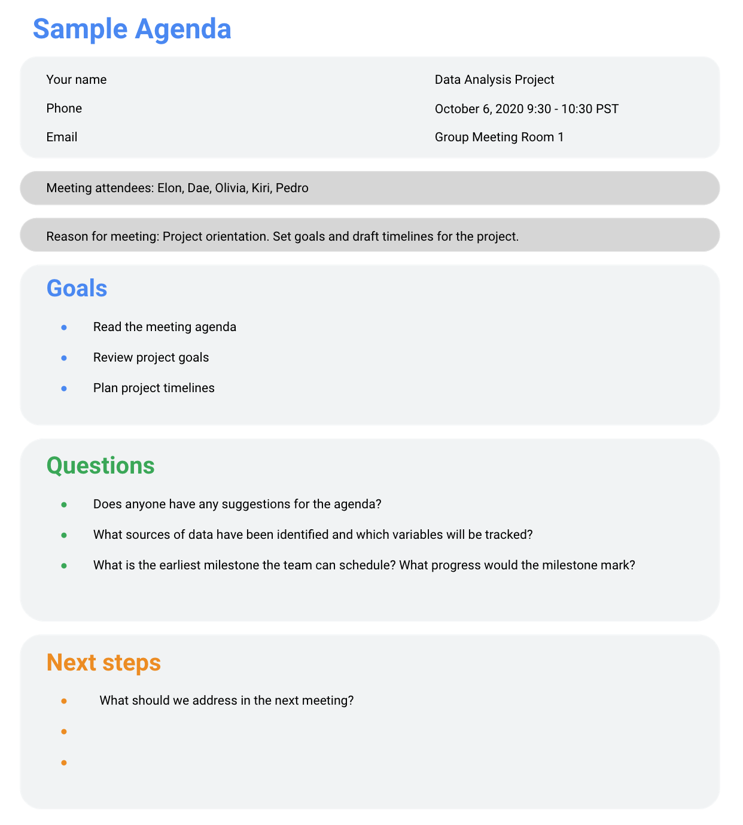

## **Sharing your agenda ahead of time**

After writing your agenda, it's time to share it with the invitees. Sharing the agenda with everyone ahead of time helps them understand the meeting goals and prepare questions, comments, or feedback. You can email the agenda or share it using another collaboration tool.

## **During the meeting**

As the leader of the meeting, it's your job to guide the data discussion. With everyone well informed of the meeting plan and goals, you can follow these steps to avoid any distractions:

* Make introductions (if necessary) and review key messages
* Present the data
* Discuss observations, interpretations, and implications of the data
* Take notes during the meeting
* Determine and summarize next steps for the group

## **After the meeting**

To keep the project and everyone aligned, prepare and distribute a brief recap of the meeting with next steps that were agreed upon in the meeting. You can even take it a step further by asking for feedback from the team.

* Distribute any notes or data
* Confirm next steps and timeline for additional actions
* Ask for feedback (this is an effective way to figure out if you missed anything in your recap)

## **A final word about meetings**

Even with the most careful planning and detailed agendas, meetings can sometimes go off track. An emergency situation might steal people’s attention. A recent decision might unexpectedly change requirements that were previously discussed and agreed on. Action items might not apply to the current situation. If this happens, you might be forced to shorten or cancel your meeting. That's all right; just be sure to discuss anything that impacts your project with your manager or stakeholders and reschedule your meeting after you have more information.

[**FROM CONFLICT TO COLLABORATION**](https://www.coursera.org/learn/ask-questions-make-decisions/lecture/lb4DS/from-conflict-to-collaboration)

A conflict can pop up for a variety of reasons:

Maybe a stakeholder misunderstood the possible outcomes for your project;

maybe you and your team members have very different work styles;

or maybe an important deadline is approaching and people are on edge.

**Mismatched expectations and miscommunications are some of the most common reasons conflicts happen**.

Maybe you weren't clear on who was supposed to clean a dataset and nobody cleaned it, delaying a project.

Or maybe a teammate sent out an email with all of your insights included, but didn't mention it was your work.

While it can be easy to take conflict personally, **it's important to try and be objective and stay focused on the team's goals.**

Believe it or not, tense moments can actually be opportunities to re-evaluate a project and maybe even improve things. So when a problem comes up, there are a few ways you can flip the situation to be more productive and collaborative. One of the best ways you can shift a situation from problematic to productive is to just **re-frame the problem**. Instead of focusing on what went wrong or who to blame, change the question you're starting with. **Try asking, how can I help you reach your goal?** This creates an opportunity for you and your team members to work together to find a solution instead of feeling frustrated by the problem.

Discussion is key to conflict resolution. If you find yourself in the middle of a conflict, try to communicate, start a conversation or ask things like, are there other important things I should be considering? This gives your team members or stakeholders a chance to fully lay out your concerns.

But **if you find yourself feeling emotional, give yourself some time to cool off** so you can go into the conversation with a clearer head. If I need to write an email during a tense moment, I'll actually save it to drafts and come back to it the next day to reread it before sending to make sure that I'm being level-headed.

If you find you don't understand what your team member or stakeholder is asking you to do, **try to understand the context of their request**. Ask them **what** their **end goal** is, **what story** they're trying to tell with the data or **what the big picture** is.

By **turning moments of potential conflict into opportunities to collaborate and move forward**, you can resolve tension and get your project back on track. Instead of saying, "There's no way I can do that in this time frame," try to re-frame it by saying, **"I would be happy to do that, but I'll just take this amount of time, let's take a step back so I can better understand what you'd like to do with the data and we can work together to find the best path forward."**

Learning how to work with new team members can be a big challenge in starting a new role or a new project but with the skills you've picked up in these videos, you'll be able to start on the right foot with any new team you join. So far, you've learned about balancing the needs and expectations of your team members and stakeholders. You've also covered how to make sense of your team's roles and focus on the project objective, the importance of clear communication and communication expectations in a workplace, and how to balance the limitations of data with stakeholder “asks”. Finally, we covered how to have effective team meetings and how to resolve conflicts by thinking collaboratively with your team members. Hopefully now you understand how important communication is to the success of a data analyst. These communication skills might feel a little different from some of the other skills you've been learning in this program, but they're also an important part of your data analyst toolkit and your success as a professional data analyst. Just like all of the other skills you're learning right now, your communication skills will grow with practice and experience.

[**COMMUNICATING CHALLENGES**](https://www.coursera.org/learn/ask-questions-make-decisions/discussionPrompt/HLyUW/communicating-challenges)

[**NATHAN: FROM THE U.S. MARINE CORPS TO DATA ANALYTICS**](https://www.coursera.org/learn/ask-questions-make-decisions/lecture/HKoHh/nathan-from-the-u-s-marine-corps-to-data-analytics)

The things that were instilled in me in the Marines that I use to this very day would be attention to detail. That's super important in the military overall, but especially in field artillery. Secondly, is the importance of communication. You have your own details locked in. You need to make sure that those are communicated really clearly to other people that you're working with and the third would be collaboration. In the military teamwork makes the dream work. You really rely on the team. That's definitely been the case in my post Marine Corps career and jobs.

# 

# **GLOSSARY TERMS FROM MODULE 4**

## **Terms and definitions for Course 2, Module 4**

**Cloud:** A place to keep data online, rather than a computer hard drive

**Reframing:** Restating a problem or challenge, then redirecting it toward a potential resolution

**Turnover rate:** The rate at which employees voluntarily leave a company

**COURSE 4 CHALLENGE**

**COURSE WRAP-UP**